June 16, 2016

To Whom It May Concern:

In compliance with Ed Code 47614.5, Yuba Environmental Science Charter Academy is physically located in the attendance area of Dobbins Elementary in which 70 percent or more of the pupil enrollment is eligible for free or reduced priced meals. Yuba Environmental Science Charter Academy gives a preference in admissions to pupils who are currently enrolled in Dobbins Elementary and to pupils who reside in the Dobbins Elementary attendance area where Yuba Environmental Science Charter Academy is located. This is effective for the 2016-2017 school year.
Thank you,
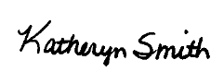
Katheryn Smith
Principal
YES Charter Academy

