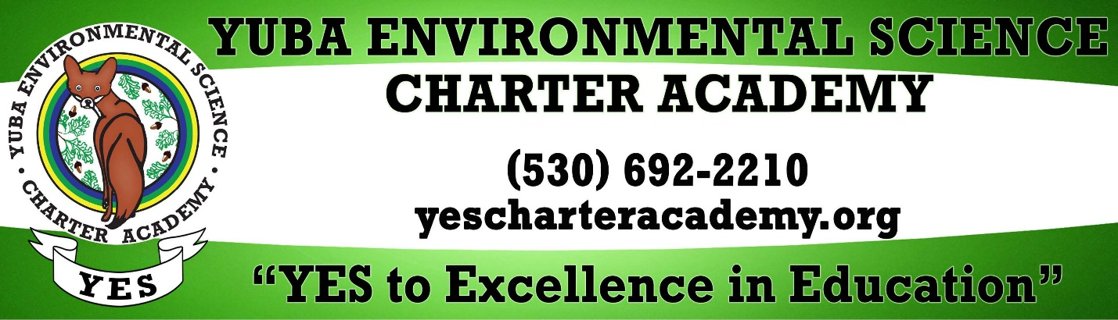
Elementary 6th grade School Teacher - YES Charter Academy
About the Employer
YES Charter Academy is a free TK–11 public charter school dedicated to hands-on, science-based learning rooted in curiosity, exploration, and environmental stewardship. Our mission is to cultivate a nurturing educational environment that pairs rigorous scientific inquiry with the highest standards of academic and moral conduct. Through our SPARRK values, we empower students to become: • S - Stewards of the environment • P - Positive Team Players • A- Academic Masters • R - Responsible Citizens • R - Resourceful • K - Kind Located in a rural, nature-rich setting, our program emphasizes experiential learning, collaboration, and strong relationships among students, staff, and families. Teachers at YES play a vital role in shaping a dynamic, engaging learning environment that extends beyond the classroom.
Job Summary
The Elementary Teacher is responsible for creating a safe, engaging, and academically rigorous classroom environment that fosters critical thinking, curiosity, and a strong foundation of knowledge. Teachers at YES Charter Academy lead self-contained, often combination-grade classrooms and teach multiple subject areas through integrated, project-based and hands-on learning approaches. As a core member of our instructional team, the teacher collaborates closely with colleagues, support staff, and families to support student growth and uphold the mission and values of the school. This role requires adaptability, creativity, and a deep commitment to student success, both academically and socially. Minimum Qualifications: • Bachelor’s Degree • Valid California Multiple Subject Teaching Credential (Intern, Preliminary, or Clear) • Commitment to working in a rural, environmental science-focused school setting • Strong classroom management skills and ability to adapt to a dynamic environment Preferred Qualifications: • Experience teaching in combination-grade classrooms • Background or interest in environmental science, outdoor education, or project-based learning • Experience with differentiated instruction and diverse student populations General Qualifications: • Strong alignment with the mission, vision, and values of YES Charter Academy • Excellent written and verbal communication skills • Ability to build positive relationships with students, families, and colleagues • Strong organizational, problem-solving, and time management skills • Ability to work both independently and collaboratively Employment Requirements: • Clear TB test • DOJ and FBI fingerprint clearance • Verification of eligibility to work in the United States Please see the attached YES Elementary Teacher Job Description for a full list of duties, responsibilities, and qualifications. Why Join YES Charter Academy? At YES, teaching is more than delivering in
Requirements / Qualifications
Specific Qualifications: • Bachelor’s Degree • Possession of a valid Multiple Subject (internship, preliminary or clear) California Teaching Credential • Desire to teach in an Environmental Science school in a rural countryside setting • Confident in managing student behavior • Ability to work under pressure and adapt to change easily General Qualifications: • Must believe in YES Charter Academy’s Mission, Vision and core values • Must have excellent communication skills, both oral and written, with the ability to foster positive working relationships • Must be able to interact with stakeholders at all levels (including staff, parents, students, and community members) in a respectful manner and provide excellent customer service • Must be able to work collaboratively in a team environment • Must have strong organizational, problem-solving, and time-management skills • Must attend and participate in YES staff meetings as required • Must attend and participate in YES training as required Employment Requirements: • Clear TB test • DOJ and FBI fingerprint clearance • Verification of eligibility to work in the United States
Possession of a valid Multiple Subject (internship, preliminary or clear) California Teaching Credential
Comments and Other Information
About YES Charter Academy: YES Charter Academy is a free public TK–8 charter school dedicated to hands-on, science-based learning rooted in curiosity, exploration, and environmental stewardship. Our mission is to cultivate a nurturing educational environment that pairs rigorous scientific inquiry with the highest standards of academic and moral conduct. Through our SPARRK values, we empower students to become: • S - Stewards of the environment • P - Positive Team Players • A- Academic Masters • R - Responsible Citizens • R - Resourceful • K - Kind Located in a rural, nature-rich setting, our program emphasizes experiential learning, collaboration, and strong relationships among students, staff, and families. Teachers at YES play a vital role in shaping a dynamic, engaging learning environment that extends beyond the classroom. Why Join YES Charter Academy? At YES, teaching is more than delivering instruction, it is about inspiring curiosity, fostering connection, and helping students discover their place in the world. Our educators are part of a collaborative, mission-driven team that values creativity, innovation, and meaningful relationships.

